Lab 5 - Retrieving Data from the Database
Step 1: Retrieving all products (code snippet from Program.cs) –
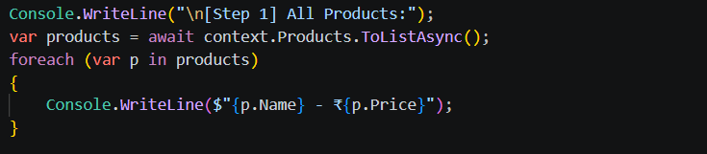
Step 2: Finding by ID (code snippet from Program.cs) –
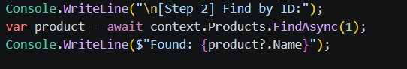
Step 3: FirstOrDefault with Condition (code snippet from Program.cs) –
CODE OUTPUT:
